**IDEATION PHASE**

**BRAINSTORM & IDEA PRIORITIZATION**

|  |  |
| --- | --- |
| **Date** | **11 October 2022** |
| **Team Id** | **PNT2022TMID33498** |
| **Project name** | **IOT based smart crop protection system for agriculture** |
| **Maximum Marks** | **4** |

**STEP 1:**

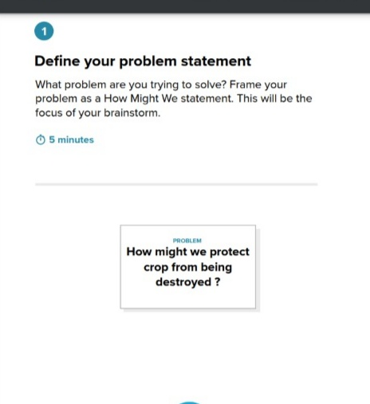

**STEP 2 : Brainstorming , Idea Listing & Grouping:**

**GAYATHRI L**

The IOT device is used to indicate the farmer by a message while someone enter into farm and we are used SD card to store some sound to fear the animals.

This whole project is work on 12 DC supply from battery .W e used solar panel t charge the battery.

The smart protection system defines that this project help to farmer for protection of system.

**BHUVANESWARI P**

Improved livestock farming and it is realtime crop monitoring.

Effective accuration and adaptive.

Sensors to detect if there is any disease

**KANIMOZHI T**

Send intimation message to user where there is any movement of animals activities.

Alarm to scare small predator like birds so on…

Ultrasonic sensors are used to detect the animal movement.

**GOPIKA S**

**GROUP IDEAS:**

Highly flexible and more accuration .

Sensors to detect the any movement of the animals.

Necessary Communication Interface.

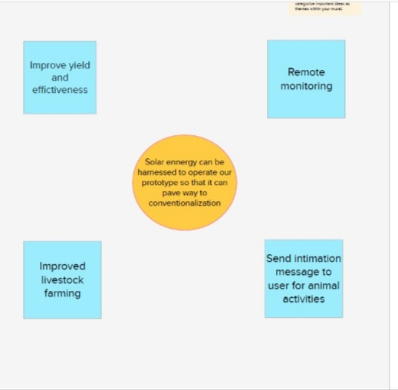

**STEP 3:**

**IDEA PRIORITIZATION**

